
PROJECT REPORT
On
devHeal
SUBMITTED TO: SUBMITTED BY:
Er. Rahul Singh Jeewan Kalia(13BCS8039) Hardeep Singh (13BCS8028)
Bharti Devi (13BCS8099)

List of Contents

- Introduction to .Net Framework
2. About the project
3. Front & Back End
3.1 Introduction to C#.net
3.2 Database
4.System Requirements
5.DevHeal(Concept)
6. Snapshots
7. Bibliography
8.conclusion

ACKNOWLEDGEMENT

At the very outset, I am highly indebted to Chandigarh University, Gharuan for giving me an opportunity to carry out my project “devHeal” at their esteemed organization. I would specially thank MR. Rahul Singh, Project Guide, for giving time and guidance throughout my training without whom it would have been impossible to attain success.

I am highly grateful to the Amit Verma, HOD CSE, Chandigarh University, Gharuan, for providing this opportunity to carry out project .I would like to expresses my gratitude to other faculty members of Computer Science & Engineering department CU, Gharuan for providing academic inputs, guidance & encouragement throughout the training period.

My heartiest thanks to Trainees and employees at the University for helping me throughout the project tenure.

I would also like to thank my team members who worked with me and our combined efforts lead to the completion of the project.
Finally, I express my indebtedness to all who have directly or indirectly contributed to the successful completion of my Project.
Jeewan Kalia
Hardeep Singh
Bharti Devi

About the Project

This is a project report on “devHeal”. During the making/developing of this project we explored new ideas and functionality behind the working on C#.net.
This project is the output of our planning, schedule, programming skill and the hard work, and this report reflects our steps taken at various levels of programming skill, planning and schedule.
With the goal of decreasing human effort and increasing the work efficiency the below software is formulated. The given application is expandable with new features can be integrated if further work is put onto it.

Introduction to .Net Framework
.NET Framework (pronounced dot net) is a software framework developed by Microsoft that runs primarily on Microsoft Windows. It includes a large library and provides language interoperability (each language can use code written in other languages) across several programming languages. Programs written for .NET Framework execute in a software environment (as contrasted to hardware environment), known as the Common Language Runtime (CLR), an application virtual machine that provides services such as security, memory management, and exception handling. The class library and the CLR together constitute .NET Framework.
.NET Framework's Framework Class Library provides user interface, data access, database connectivity, cryptography, web application development, numeric algorithms, and network communications. Programmers produce software by combining their own source code with .NET Framework and other libraries. .NET Framework is intended to be used by most new applications created for the Windows platform. Microsoft also produces an integrated development environment largely for .NET software called Visual Studio.
A programming infrastructure created by Microsoft for building, deploying, and running applications and services that use .NETtechnologies, such as desktop applications and Web services.
In a perfect world, you wouldn't need .NET Framework. The makers of all your crucial applications would have the time and resources to fully patch together their applications into self-contained packages, because developing for Windows would be an intuitive, mostly high-level process that independent developers could nail down in fairly quick order. So nobody besides developers would need a package like .NET, which provides applications with an orderly way to access databases, web services, and other communication tools.

Front & Back End

INTRODUCTION TO C#.Net:-
C♯ (pronounced as see sharp) is a multi-paradigm programming language encompassing strong typing,imperative, declarative, functional, generic, object-oriented (class-based), and component-oriented programming disciplines. It was developed by Microsoft within its .NET initiative and later approved as a standard by Ecma (ECMA-334) and ISO (ISO/IEC 23270:2006). C♯ is one of the programming languages designed for the Common Language Infrastructure. C♯ is built on the syntax and semantics of C++, allowing C programmers to take advantage of .NET and the common language runtime.
C♯ is intended to be a simple, modern, general-purpose, object-oriented programming language. Its development team is led by Anders Hejlsberg. The most recent version is C♯ 5.0, which was released on August 15, 2012.
Name:-
The name "C sharp" was inspired by musical notation where a sharp indicates that the written note should be made a semitone higher in pitch.^{[7]}This is similar to the language name of C++, where "++" indicates that a variable should be incremented by 1. The sharp symbol also resembles a ligature of four "+" symbols (in a two-by-two grid), further implying that the language is an increment of C++.
Due to technical limitations of display (standard fonts, browsers, etc.) and the fact that the sharp symbol (U+266F ♯ music sharp sign (HTML:&#9839;)) is not present on the standard keyboard, the number sign (U+0023 # number sign (HTML: &#35;)) was chosen to represent the sharp symbol in the written name of the programming language. This convention is reflected in the ECMA-334 C# Language Specification. However, when it is practical to do so (for example, in advertising or in box art), Microsoft uses the intended musical symbol.
The "sharp" suffix has been used by a number of other .NET languages that are variants of existing languages, including J# (a .NET language also designed by Microsoft that is derived from Java 1.1), A# (from Ada), and the functional programming language F#. The original implementation of Eiffel for .NET was called Eiffel#, a name retired since the full Eiffel language is now supported. The suffix has also been used for libraries, such as Gtk# (a .NET wrapper for GTK+ and other GNOME libraries) and Cocoa# (a wrapper for Cocoa)

History:-
During the development of the .NET Framework, the class libraries were originally written using a managed code compiler system called Simple Managed C(SMC). In January 1999, Anders Hejlsberg formed a team to build a new language at the time called Cool, which stood for "C-like Object Oriented Language". Microsoft had considered keeping the name "Cool" as the final name of the language, but chose not to do so for trademark reasons. By the time the .NET project was publicly announced at the July 2000 Professional Developers Conference, the language had been renamed C#, and the class libraries andASP.NET runtime had been ported to C#.
C#'s principal designer and lead architect at Microsoft is Anders Hejlsberg, who was previously involved with the design of Turbo Pascal, Embarcadero Delphi(formerly CodeGear Delphi, Inprise Delphi and Borland Delphi), and Visual J++. In interviews and technical papers he has stated that flaws^{[citation needed]} in most major programming languages (e.g. C++, Java, Delphi, and Smalltalk) drove the fundamentals of the Common Language Runtime (CLR), which, in turn, drove the design of the C# language itself.
James Gosling, who created the Java programming language in 1994, and Bill Joy, a co-founder of Sun Microsystems, the originator of Java, called C# an "imitation" of Java; Gosling further said that "[C# is] sort of Java with reliability, productivity and security deleted." Klaus Kreft and Angelika Langer (authors of a C++ streams book) stated in a blog post that "Java and C# are almost identical programming languages. Boring repetition that lacks innovation," "Hardly anybody will claim that Java or C# are revolutionary programming languages that changed the way we write programs," and "C# borrowed a lot from Java - and vice versa. Now that C# supports boxing and unboxing, we'll have a very similar feature in Java." In July 2000, Anders Hejlsberg said that C# is "not a Java clone" and is "much closer to C++" in its design.
Since the release of C# 2.0 in November 2005, the C# and Java languages have evolved on increasingly divergent trajectories, becoming somewhat less similar. One of the first major departures came with the addition of generics to both languages, with vastly different implementations. C# makes use of reification to provide "first-class" generic objects that can be used like any other class, with code generation performed at class-load time. By contrast, Java's generics are essentially a language syntax feature, and they do not affect the generated byte code, because the compiler performs type erasure on the generic type information after it has verified its correctness.
Furthermore, C# has added several major features to accommodate functional-style programming, culminating in the LINQ extensions released with C# 3.0 and its supporting framework of lambda expressions, extension methods, and anonymous types. These features enable C# programmers to use functional programming techniques, such as closures, when it is advantageous to their application. The LINQ extensions and the functional imports help developers reduce the amount of "boilerplate" code that is included in common tasks like querying a database, parsing an xml file, or searching through a data structure, shifting the emphasis onto the actual program logic to help improve readability and maintainability.
C# used to have a mascot called Andy (named after Anders Hejlsberg). It was retired on Jan 29, 2004.
C# was originally submitted for review to the ISO subcommittee JTC 1/SC 22 under ISO/IEC 23270:2003, which is now withdrawn. It was then approved under ISO/IEC 23270:2006.
Common Type System:-
C# has a unified type system. This unified type system is called Common Type System (CTS).
A unified type system implies that all types, including primitives such as integers, are subclasses of the System.Object class. For example, every type inherits aToString() method.

Categories of data types
CTS separates data types into two categories:
- Reference types
- Value types
Instances of value types do not have referential identity nor referential comparison semantics - equality and inequality comparisons for value types compare the actual data values within the instances, unless the corresponding operators are overloaded. Value types are derived from System.ValueType, always have a default value, and can always be created and copied. Some other limitations on value types are that they cannot derive from each other (but can implement interfaces) and cannot have an explicit default (parameterless) constructor. Examples of value types are all primitive types, such as int (a signed 32-bit integer),float (a 32-bit IEEE floating-point number), char (a 16-bit Unicode code unit), and System.DateTime (identifies a specific point in time with nanosecond precision). Other examples are enum (enumerations) and struct (user defined structures).
In contrast, reference types have the notion of referential identity - each instance of a reference type is inherently distinct from every other instance, even if the data within both instances is the same. This is reflected in default equality and inequality comparisons for reference types, which test for referential rather than structural equality, unless the corresponding operators are overloaded (such as the case for System.String). In general, it is not always possible to create an instance of a reference type, nor to copy an existing instance, or perform a value comparison on two existing instances, though specific reference types can provide such services by exposing a public constructor or implementing a corresponding interface (such as ICloneable or IComparable). Examples of reference types are object (the ultimate base class for all other C# classes), System.String (a string of Unicode characters), and System.Array (a base class for all C# arrays).
Both type categories are extensible with user-defined types.

Boxing and unboxing:-
Boxing is the operation of converting a value-type object into a value of a corresponding reference type. Boxing in C# is implicit.
Unboxing is the operation of converting a value of a reference type (previously boxed) into a value of a value type. Unboxing in C# requires an explicit type cast. A boxed object of type T can only be unboxed to a T (or a nullable T).
Example:
int foo1 = 42; // Value type.
object bar = foo1; // foo is boxed to bar.
int foo2 = (int)bar; // Unboxed back to value type.

Generics[edit]
Generics were added to version 2.0 of the C# language. Generics use type parameters, which make it possible to design classes and methods that do not specify the type used until the class or method is instantiated. The main advantage is that one can use generic type parameters to create classes and methods that can be used without incurring the cost of runtime casts or boxing operations, as shown here:^{[37]}
// Declare the generic class.

public class GenericList<T>
{
void Add(T input) { }
}

class TestGenericList
{
private class ExampleClass { }
static void Main()
{
// Declare a list of type int.
GenericList<int> list1 = new GenericList<int>();

// Declare a list of type string.
GenericList<string> list2 = new GenericList<string>();

// Declare a list of type ExampleClass.
GenericList<ExampleClass> list3 = new GenericList<ExampleClass>();
}
}
When compared with C++ templates, C# generics can provide enhanced safety, but also have somewhat limited capabilities. For example, it is not possible to call arithmetic operators on a C# generic type.

Distinguishing features:-
By design, C# is the programming language that most directly reflects the underlying Common Language Infrastructure (CLI).^{[33]} Most of its intrinsic types correspond to value-types implemented by the CLI framework. However, the language specification does not state the code generation requirements of the compiler: that is, it does not state that a C# compiler must target a Common Language Runtime, or generate Common Intermediate Language (CIL), or generate any other specific format. Theoretically, a C# compiler could generate machine code like traditional compilers of C++ or Fortran. Some notable features of C# that distinguish it from C and C++ (and Java, where noted) are:
- C# supports strongly typed implicit variable declarations with the keyword var, and implicitly typed arrays with the keyword new[] followed by a collection initializer.
- Meta programming via C# attributes is part of the language. Many of these attributes duplicate the functionality of GCC's and VisualC++'s platform-dependent preprocessor directives.
- Like C++, and unlike Java, C# programmers must use the keyword virtual to allow methods to be overridden by subclasses.
- Extension methods in C# allow programmers to use static methods as if they were methods from a class's method table, allowing programmers to add methods to an object that they feel should exist on that object and its derivatives.
- The type dynamic allows for run-time method binding, allowing for JavaScript like method calls and run-time object composition.
- C# has support for strongly-typed function pointers via the keyword delegate.
- Like the Qt framework's pseudo-C++ signal and slot, C# has semantics specifically surrounding publish-subscribe style events, though C# uses delegates to do so.
- C# offers Java-like synchronized method calls, via the attribute [MethodImpl(MethodImplOptions.Synchronized)], and has support for mutually-exclusive locks via the keyword lock.
- The C# languages does not allow for global variables or functions. All methods and members must be declared within classes. Static members of public classes can substitute for global variables and functions.
- Local variables cannot shadow variables of the enclosing block, unlike C and C++.
- A C# namespace provides the same level of code isolation as a Java package or a C++ namespace, with very similar rules and features to a package.
- C# supports a strict Boolean data type, bool. Statements that take conditions, such as while and if, require an expression of a type that implements the trueoperator, such as the boolean type. While C++ also has a boolean type, it can be freely converted to and from integers, and expressions such as if(a) require only that a is convertible to bool, allowing a to be an int, or a pointer. C# disallows this "integer meaning true or false" approach, on the grounds that forcing programmers to use expressions that return exactly bool can prevent certain types of programming mistakes common in C or C++ such as if (a = b) (use of assignment = instead of equality ==).
- In C#, memory address pointers can only be used within blocks specifically marked as unsafe, and programs with unsafe code need appropriate permissions to run. Most object access is done through safe object references, which always either point to a "live" object or have the well-defined null value; it is impossible to obtain a reference to a "dead" object (one that has been garbage collected), or to a random block of memory. An unsafe pointer can point to an instance of a value-type, array, string, or a block of memory allocated on a stack. Code that is not marked as unsafe can still store and manipulate pointers through theSystem.IntPtr type, but it cannot dereference them.
- Managed memory cannot be explicitly freed; instead, it is automatically garbage collected. Garbage collection addresses the problem of memory leaks by freeing the programmer of responsibility for releasing memory that is no longer needed.
- In addition to the try...catch construct to handle exceptions, C# has a try...finally construct to guarantee execution of the code in the finally block, whether an exception occurs or not.
- Multiple inheritance is not supported, although a class can implement any number of interfaces. This was a design decision by the language's lead architect to avoid complication and simplify architectural requirements throughout CLI. When implementing multiple interfaces that contain a method with the same signature, C# allows the programmer to implement each method depending on which interface that method is being called through, or, like Java, allows the programmer to implement the method once and have that be the single invocation on a call through any of the class's interfaces.
- C#, unlike Java, supports operator overloading. Only the most commonly overloaded operators in C++ may be overloaded in C#.
- C# is more type safe than C++. The only implicit conversions by default are those that are considered safe, such as widening of integers. This is enforced at compile-time, during JIT, and, in some cases, at runtime. No implicit conversions occur between booleans and integers, nor between enumeration members and integers (except for literal 0, which can be implicitly converted to any enumerated type). Any user-defined conversion must be explicitly marked as explicit or implicit, unlike C++ copy constructors and conversion operators, which are both implicit by default.
- C# has explicit support for covariance and contravariance in generic types, unlike C++ which has some degree of support for contravariance simply through the semantics of return types on virtual methods.
- Enumeration members are placed in their own scope.
- C# provides properties as syntactic sugar for a common pattern in which a pair of methods, accessor (getter) and mutator (setter) encapsulate operations on a single attribute of a class. No redundant method signatures for the getter/setter implementations need be written, and the property may be accessed using attribute syntax rather than more verbose method calls.
- Checked exceptions are not present in C# (in contrast to Java). This has been a conscious decision based on the issues of scalability and versionability.
- Though primarily an imperative language, C# 2.0 offered limited support for functional programming through first-class functions and closures in the form of anonymous delegates. C# 3.0 expanded support for functional programming with the introduction of a light weight syntax for lambda expressions, extension methods (an affordance for modules), and a list comprehension syntax in the form of a "query comprehension" language.

Microsoft Visual C Sharp .Net:-
Microsoft Visual C# is Microsoft's implementation of the C# specification, included in the Microsoft Visual Studio suite of products. It is based on the ECMA/ISO specification of the C# language, which Microsoft also created. While multiple implementations of the specification exist, Visual C# is by far the one most commonly used.^{[1]} In most contexts, an unqualified reference to "C#" is taken to mean "Visual C#."
The term Visual denotes a brand-name relationship with other Microsoft programming languages such as Visual Basic,Visual FoxPro, Visual J# and Visual C++. All of these products are packaged with a graphical IDE and support rapid application development of Windows-based applications.
Visual C# is currently used in development of Windows and Xbox Live games via Microsoft XNA, which allows game developers to create and share their games with other gamers. Visual C# is also heavily used by ASP.NET web sites and standalone applications based on the .NET Framework. Note: As of October 2012 Microsoft has ended support and future releases of XNA.

IDE:-

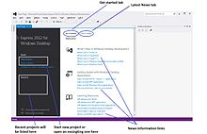

Visual C sharp start page
When you start Visual C#, Start Page is displayed. Start Page has two columns; the left column holds Start and Recent sections. These sections contain options for developers to create a new application or work with an existing one, respectively.
Visual C# places Get Started and Latest News tabs in the left column so developers can find useful information about application development, resources, and a tutorial. It is necessary for the user to have an internet connection to access the latest news.
Menu bar provides functions to developers for coding, maintaining and executing their programs. Menu bar contains:
- DEBUG: used for compiling, debugging and running apps.
- TEAM: contains functions to connect to Team Foundation Server.
- FORMAT: contains commands to arrange and modify Form’s controls.
- TOOLS: contains commands to customize the IDE.

Developing Windows Store Application:-
Microsoft designed Windows 8 with the intent to provide a platform to the next generation of mobile devices. Users install Windows 8 operating system on their laptop can feel like they are using a tablet or smartphone. Users can input data into their system by using a touch sensitive screen and they can know their system location or orientation if the device hardware supports appropriate sensors. Developers can upload applications to Windows Store to share with other people. For this reason, those applications are known as Windows Store apps.

Multitasking:-
Developers use multitasking approach while developing an application when they want to achieve:
Responsiveness: If programmers divided an application into small threads and assigned a short time period to each thread, users can feel that the application can run multi tasks at the same time. However, this is not true multitasking because these threads share the computing time of the processor. The advantage will be lost if there was a thread which dominated time consuming. In the past, it was not easy to implement true multitasking in an application. Now, Windows 8 with Windows Runtime provides many API functions to address this issue.
Scalability: Scalability can be increased if an application handles computing resource better. Developers identify which parts of an application can be processed in parallel manner and make an executing schedule for them. The MPI (Message Passing Interface) protocol provides mechanism so that parallel tasks can communicate to each other by sending a message.
In a multiprocessors system or a system with multicore processor, an application can execute a number of concurrent tasks, which will not exceed the number of processors (or cores). If an application always uses all of these processors, it will be finished very quickly. Programmers have to answer the following questions then they want to put their applications in multitasking mode:
- How to identify which parts are parallel
- How to ensure that number of concurrent task at a time will not exceed the number of processors in the system
- Suppose that there is a task waiting for an I/O operation, how to recognize this task and indicate the application to switch to another task
- Which sign show that a task is completed
Developers use Task class and System.Threading.Tasks namespace to address this issue. A concurrent task is an instance of Task class, it is used to execute inside code block. For example, to run a job named doThisWork, a Task object is defined as follows:
Task task = new Task(doThisWork);

private void doThisWork (){ // The task runs this code when it is started ...}
and execute this Task by Start method:
Task task = new Task(...);
task.Start();

Asynchronous operations:-
User interface also is a concurrent task, and users want to interact with the application even when this application is doing another complicated task. The answer to this problem is executing all the tasks in asynchronous manner. Visual C# provides a platform for developers to overcome the difficulty of defining asynchronous methods.
An asynchronous method is the method in executing mode will not block current thread. It returns control permission to calling environment as soon as possible. Programmers use await and async keywords to declare a synchronous method, for example:
private async void slowMethod()
{
await doFirstLongRunningOperation();
await doSecondLongRunningOperation();
await doThirdLongRunningOperation();
messages.Text = "Processing Complete";
}

Database

In very simple terms, a database is a collection of data. Some like to think of a database as an organized mechanism that has the capability of storing information, through which a user can retrieve stored information in an effective and efficient manner.
People use databases every day without realizing it. A phone book is a database. The data contained consists of individuals' names, addresses, and telephone numbers. The listings are alphabetized or indexed, which allows the user to reference a particular local resident with ease. Ultimately, this data is stored in a database somewhere on a computer. After all, each page of a phone book is not manually typed each year a new edition is released.
The database has to be maintained. As people move to different cities or states, entries may have to be added or removed from the phone book. Likewise, entries will have to be modified for people changing names, addresses, or telephone numbers.
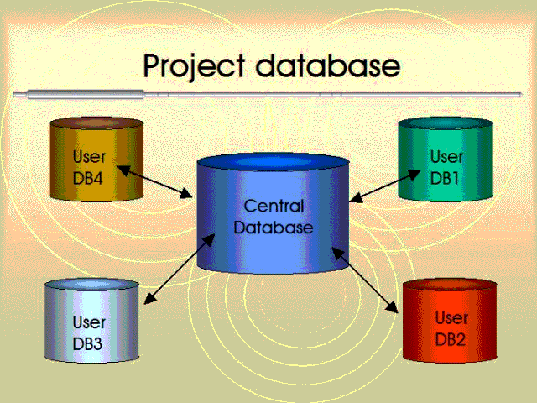
Fig 3.1: Project Database
An Introduction to Relational Database
A relational database is a database divided into logical units called tables, where tables are related to one another within the database. A relational database allows data to be broken down into logical, smaller, manageable units, allowing for easier maintenance and providing more optimal database performance according to the level of organization. In this tables are related to one another through a common key (data value) in a relational database.
Introduction to the Database Query
In this seventh hour, you will learn about database queries, which involve the use of the SELECT statement. The SELECT statement is the most frequently used of all SQL commands after a database's establishment. The SELECT statement allows you to view data that is stored in the database.
The highlights of this Section include
- What a database query is
- How to use the SELECT statement
- Adding conditions to queries using the WHERE clause
- Using column aliases
- Selecting data from another user's table
ADO.NET
ADO.NET provides consistent access to data sources such as Microsoft SQL Server, Data-sharing consumer applications can use ADO.NET to connect to these data sources and retrieve, manipulate, and update data.
ADO.NET cleanly factors data access from data manipulation into discrete components that can be used separately or in tandem. ADO.NET includes .NET Framework data providers for connecting to a database, executing commands, and retrieving results. Those results are either processed directly, or placed in an ADO.NET DataSet object in order to be exposed to the user in an ad-hoc manner, combined with data from multiple sources, or remote between tiers. The ADO.NET.DataSet object can also be used independently of a .NET Framework data provider to manage data local to the application or sourced from XML.ADO.NET provides functionality to developers writing managed code similar to the functionality provided to native COM developers by ADO.
ADO.NET is a set of computer software components that can be used by programmers to access data and data services. It is a part of the base class library that is included with the Microsoft .NET Framework. It is commonly used by programmers to access and modify data stored in relational database systems, though it can also be used to access data in non-relational sources. ADO.NET is sometimes considered an evolution of ActiveX Data Objects (ADO) technology, but was changed so extensively that it can be conceived of as an entirely new product.

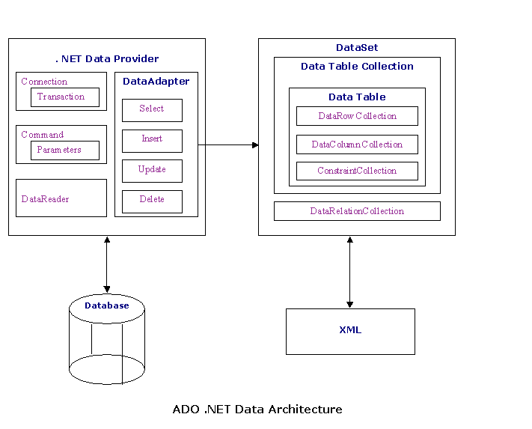Fig 3.2:ADO.NET Architecture
Data provider
These classes provide access to a data source, such as a Microsoft SQL Server or Oracle database and OLEDB data provider. Each data source has its own set of provider objects, but they each have a common set of utility classes.
Connection
Provides a connection used to communicate with the data source. Also acts as an abstract factory for command objects.
Command
Used to perform some action on the data source, such as reading, updating, or deleting relational data.
Parameter
Describes a single parameter to a command. A common example is a parameter to a stored procedure
DataAdapter
A bridge used to transfer data between a data source and a DataSet object
DataReader: Used to efficiently process a large list of results one record at a time. It allows records to be accessed in a read-only, forward-only mode, i.e., records have to be accessed in sequential order; they can neither be randomly accessed nor can a record which has been processed previously be accessed again.
DataSets
DataSets objects, a group of classes describing a simple in-memory relational database, were the star of the show in the initial release (1.0) of the Microsoft .NET Framework. The classes form a containment hierarchy:
- A DataSet object represents a schema (either an entire database or a subset of one). It can contain tables and relationships between those tables.
- A DataTable object represents a single table in the database. It has a name, rows, and columns.
- A DataView object "sits over" a DataTable and sorts the data (much like a SQL "order by" clause) and filters the records (much like a SQL "where" clause) if a filter is set. An in-memory index is used to facilitate these operations. All DataTables have a default filter, while any number of additional DataViews can be defined, reducing interaction with the underlying database and thus improving performance.
- A DataColumn represents a column of the table, including its name and type.
- A DataRow object represents a single row in the table, and allows reading and updating of the values in that row, as well as retrieving any rows that are related to it through a primary-key foreign-key relationship.
- A DataRowView represents a single row of a DataView. The distinction between a DataRow and DataRowView is important when iterating over a result set.
- A DataRelation is a relationship between tables, such as a primary-key foreign-key relationship. This is useful for enabling DataRow's functionality of retrieving related rows.
- A Constraint describes an enforced property of the database, such as the uniqueness of the values in a primary key column. As data is modified any violations that arise will cause exceptions.
- A DataSet is populated from a database by a DataAdapterwhose Connection and Command properties have been set. However, a DataSet can save its contents to XML, or populate itself from XML, making it exceptionally useful for web services, distributed computing, and occasionally-connected applications.

CONNECT
When a user connects to a database, the SQL session is initialized. The CONNECT command is used to establish a database connection. With the CONNECT command, you can either invoke a connection or change connections to the database. For example, if you are connected as USER1, you can use the CONNECT command to connect to the database as USER2. When this happens, the SQL session for USER1 is implicitly disconnected.
When you attempt to connect to a database, you are automatically prompted for a password that is associated with your current username. The username is used to authenticate yourself to the database, and the password is the key that allows entrance.
3.11 DISCONNECT and EXIT
When a user disconnects from a database, the SQL session is terminated. The DISCONNECT command is used to disconnect a user from the database. When you disconnect from the database, the software you are using may still appear to be communicating with the database, but you have lost your connection. When you use EXIT to leave the database, your SQL session is terminated and the software that you are using to access the database is normally close
3.12 SOFTWARE PROCESS
For the development of quality software, a certain predefined activities must be performed according to a predefined procedure or model. A particular model is chosen depending upon the nature, various constraints, complexities, etc. In our software Incremental model was found suited best for the problem. Therefore, we followed Incremental model for the development.
The incremental model combines elements of the linear sequential model (applied repetitively) with the iterative philosophy of prototyping. Referring to the figure below, the incremental model applies linear sequences in a staggered fashion as a calendar time progresses. Each linear sequence produces a deliverable “increment” of the software.
In this Project we are using Incremental model.
Incremental model is an evolution of waterfall model. The product is designed, implemented, integrated and tested as a series of incremental builds. It is a popular model software evolution used many commercial software companies and system vendor.
Incremental software development model may be applicable to projects where:
- Software Requirements are well defined, but realization may be delayed.
- The basic software functionality are required early

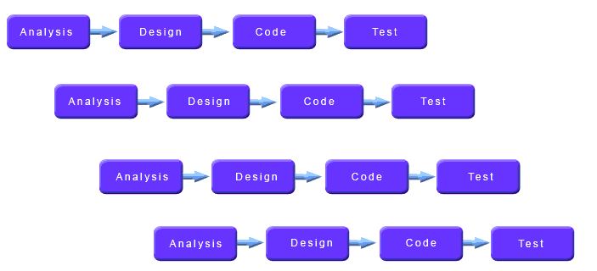
Fig 3.3: Software Process

HARDWARE & SOFTWARE
REQUIREMENT

HARDWARE
- 1.6 GHz or faster processor
- 1 GB of RAM (1.5 GB if running on a virtual machine)
- 20 GB of available hard disk space
- 5400 RPM hard disk drive
- DirectX 9-capable video card that runs at 1024 x 768 or higher display resolution

SOFTWARE
- Internet Explorer 10
- KB2883200 (available through Windows Update) is required
- For Windows Phone development:
  - Windows Phone 8.0 development requires Windows 8.1 (x64) or higher
  - Windows Phone 8.1 development requires Windows 8.1 (x86) or higher
  - For the Windows Phone emulators, Windows 8.1 (x64) Professional edition or higher, and a processor that supports Client Hyper-V and Second Level Address Translation (SLAT)

DevHeal(Concept)
Every device in today’s world need a place to be repaired or upgraded, a clinic for the machines. DevHeal is a small sized accounting software that is able to keep record of the devices that is given to a repairing store. A light weight application software that sort out and manage the accounts of that store.
WORKING OF PRESENT MANUAL SYSTEM:-
The staffs of Repair Store are involved in the following tasks.
  - Recruitment process : person have to fill recruitment form and they are provided with a worker’s id.
  - Adding transactions: Customer’s Information along with the device info and problem will be noted.
  - Mailing: Customer will be Welcomed, informed and told about the device as an updated personal conversation with the customer.

DRAWBACKS OF PRESENT SYSTEM:-
Some of the problems being faced in manual system are as follows:
1. Fast report generation is not possible.
2. Tracing a submission is difficult.
3. Information about issue/return of the device are not properly maintained.
4. No central database can be created as information is not available in database.
PROPOSED SYSTEM:-
There will be three major components :
1. Device maintenance.
2. Transaction entry.
3. Reports generation.
4.Automated Mailing

Proposed system provides with following solutions :
1. It provides "better and efficient" service to members.
2. Reduce the workload of employee.
3. Faster retrieval of information about the desired book.
4. Provide facility for proper monitoring reduce paper work and provide data security.
5. All details will be available on a click

SCREENSHOTS

- MAIN PAGE

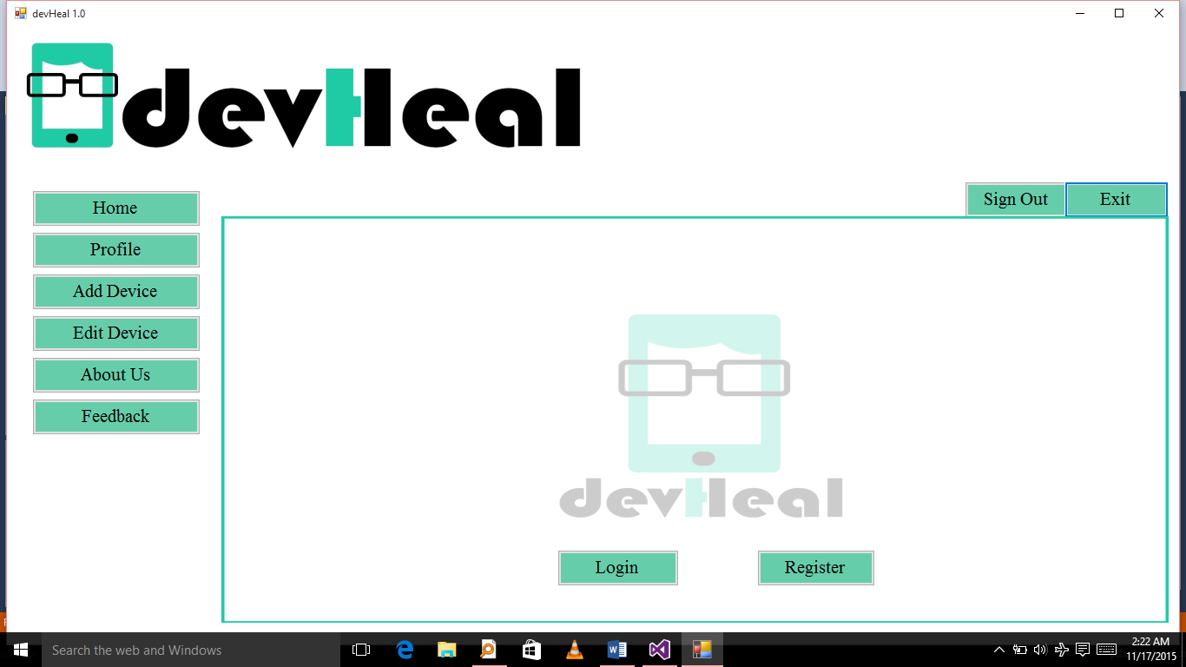

- HOME:-

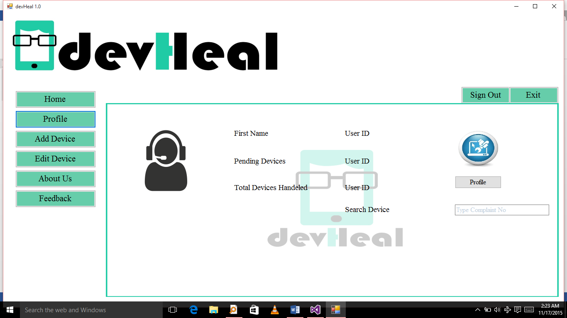

- Add Device:-

- Edit Device:-

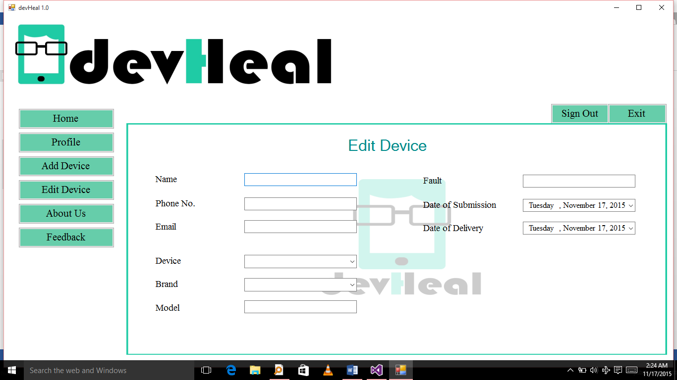

Bibliography

www.wikipedia.org
www.google.com

